**Assignment – Arranging Logistics**

Shaun Pritchard

Rasmussen College

QMB3200

Kimberly Powell

July,23 2020

**Assignment – Arranging Logistics**

In this program I ran frequency distribution queries on data sets while also showing data by state and table output for the number of presidents and an official count of each president by name. Here is the code I used below.

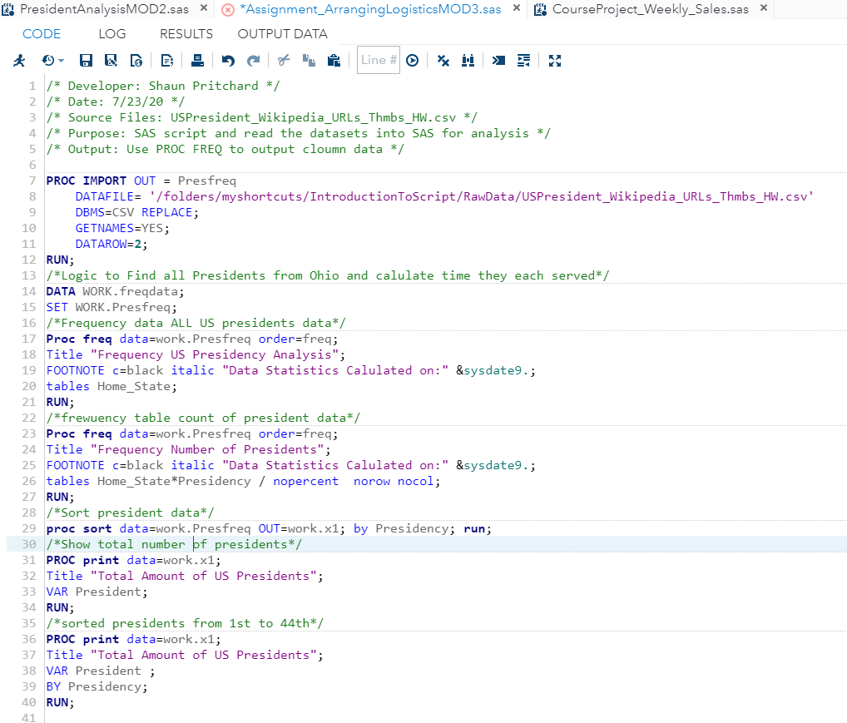

**Code Output:**

